
Mammogram Classification System
Technical Assessment Report

Submitted by: Muhammad Adeel Shah
Submitted to : FAHM Biotech
Dated : 05 June 2026

Live Links & Repositories

- Live Web Application (Frontend):
https://fahm-mammogram-classifier.vercel.app
- Live Backend API (Docs):
https://adeel41-mammogram-classifier.hf.space/docs
- Master GitHub Repository: Full-stack source code, Docker configurations, backend, frontend, and ML scripts
https://github.com/adeelshah41/fahm-technical-assessment
- Reproducible Notebook: Located at docs/cbism.ipynb for complete model training and evaluation tracking

1. Architecture Overview

The FAHM Biotech Mammogram Classifier is built as a secure, production-grade, decoupled full-stack application leveraging serverless hosting and containerized environments.

System Architecture

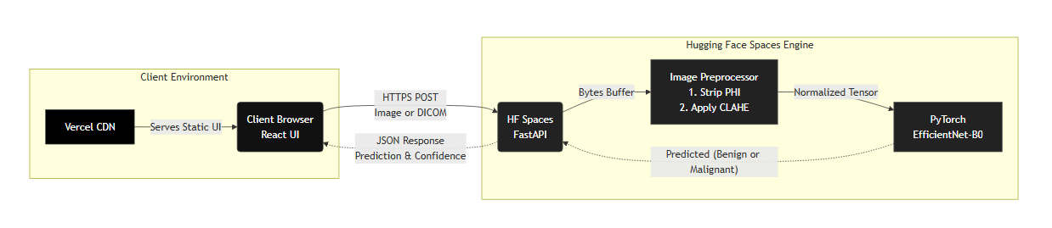

Technology Stack & Rationale
- Deep Learning Framework — PyTorch & Torchvision: Selected for its flexibility in loading pretrained backbones, easy customization of classifier heads, and widespread adoption in medical computer vision research.
- Backend API — FastAPI (Python): Chosen for its asynchronous execution, high performance, and automatic generation of OpenAPI/Swagger documentation, making it easy to test endpoints.
- Frontend Interface — React + Vite + TailwindCSS v4: Provides an extremely responsive, low-latency workstation dashboard with clean dark aesthetics, smooth micro-animations, and modular component rendering.
- Hosting Infrastructure — Vercel + Hugging Face Spaces (Dockerized): Decoupled deployment architecture completely isolates compute-intensive ML inference from frontend serving, providing robust scaling and zero downtime on a free tier.

2. Dataset Selection & Image Preprocessing

The classification model was trained and validated on the CBIS-DDSM (Curated Breast Imaging Subset of DDSM) dataset, utilizing a curated variant containing cropped Region of Interest (ROI) images mapped to pathology labels.

Class Distribution (3,566 images)
Class | Count
Malignant (Class 1) | 1,456 images
Benign / Normal (Class 0) | 2,110 images

Data Splits
Partitioned using a stratified split (70% Train / 15% Validation / 15% Test) under seed 42 to guarantee exact distribution parity across all sets.

On-the-Fly Contrast Enhancement (CLAHE)
Mammographic abnormalities such as microcalcifications and subtle masses are often tiny and hidden within dense fibroglandular breast tissue. Standard downsampling to 224 × 224 pixels obliterates these critical features.

To resolve this visual degradation, an in-memory Contrast Limited Adaptive Histogram Equalization (CLAHE) preprocessing step was introduced:
- The raw image is converted to grayscale.
- CLAHE is applied using a clip limit of 2.0 and a grid tile size of 8×8 to dynamically enhance local tissue contrast without amplifying noise.
- The image is converted back to RGB and resized using high-quality bilinear interpolation to 224 × 224 for model input.
Dataset available on Kaggle:
https://www.kaggle.com/datasets/awsaf49/cbis-ddsm-breast-cancer-image-dataset

3. Machine Learning Model Optimization

The core engine is an EfficientNet-B0 convolutional neural network pretrained on IMAGENET1K_V1. The training pipeline was restructured to mitigate overfitting and improve feature representation.

Training Optimization Workflow

Classifier Head
Custom sequential head with Dropout (p=0.4) and a linear layer outputting a single logit. The 40% dropout regularizes the network, preventing uncalibrated, overconfident predictions.
model.classifier = nn.Sequential(
nn.Dropout(p=0.4, inplace=True),
nn.Linear(in_features, 1)
)

Loss Function
Standard BCEWithLogitsLoss. The double-balancing loss bias (pos_weight) was explicitly removed as it was skewing predictions.

Optimization & Scheduling
Adam optimizer with Learning Rate 1e-4 and Weight Decay 1e-5, paired with a Cosine Annealing Learning Rate Scheduler to smoothly decay learning rates for better convergence.

Regularization & Augmentations
Strong spatial augmentations applied to enforce generalizability:
- Random Horizontal and Vertical Flips
- Rotation up to 15°
- Random Affine Translation
- Random Erasing (p = 0.2)

Early Stopping
Validation AUC-based early stopping with patience = 5 to save the best model weights before overfitting occurs.

4. Performance Metrics

Results on the held-out test set (535 images) at the default classification threshold of 0.50:
Metric | Value
AUC-ROC | 0.85
Accuracy | 76.45%
Sensitivity (Recall) | 80.28%
Specificity | 73.82%

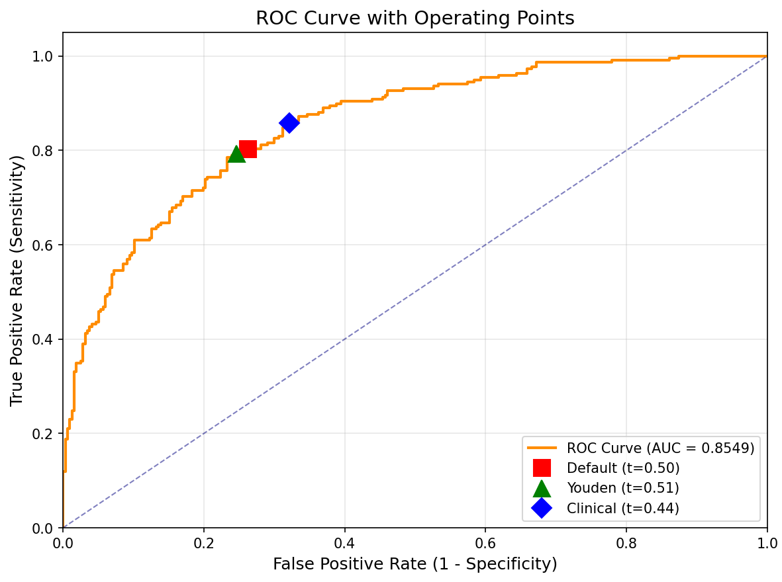

Confusion Matrix Results
Outcome | Count
True Negatives (TN) | 234
False Positives (FP) | 83
False Negatives (FN) | 43
True Positives (TP) | 175

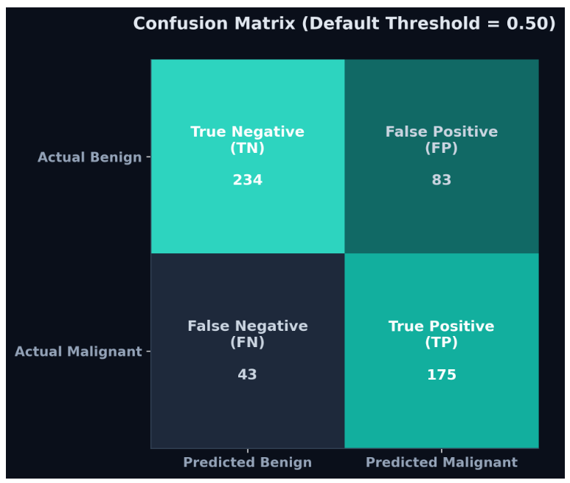

5. Class Imbalance & Why Accuracy Alone is Insufficient

In clinical screening contexts, Accuracy (the ratio of correct predictions to total predictions) is a highly misleading and dangerous metric to rely on due to Class Imbalance.

The Math of Class Imbalance

In real-world cancer screening, the patient population is heavily imbalanced: the vast majority of mammograms are normal/benign (e.g., 99.5%), and only a tiny fraction are malignant (e.g., 0.5%).

If a machine learning model is trained on this population, a completely "naïve" classifier that simply outputs "Benign" for every single image will achieve a 99.5% Accuracy.

While a 99.5% accuracy sounds outstanding on paper, the model has a 0% Sensitivity (Recall)—meaning it failed to detect a single actual cancer case.

The Clinical Catastrophe of False Negatives

In cancer screening, the primary clinical objective is triage safety (preventing missed diagnoses).

A False Positive (classifying a benign breast as malignant) causes temporary patient anxiety and leads to a follow-up ultrasound or biopsy. While undesirable, it is clinically manageable.

A False Negative (classifying a malignant tumor as benign) is a catastrophe. It means a patient with breast cancer is sent home with a clean bill of health, delaying life-saving treatment and allowing the disease to progress.

The Solution: Combined Screening Metrics

To properly evaluate a screening tool, we must ignore simple accuracy and instead look at:

Sensitivity (Recall / True Positive Rate): The percentage of actual cancers the model successfully flags (minimizes False Negatives).

Specificity (True Negative Rate): The percentage of healthy patients the model correctly identifies, preventing radiologist burnout and unnecessary recall procedures (minimizes False Positives).

AUC-ROC (Area Under the Receiver Operating Characteristic Curve): Evaluates the model's overall diagnostic power across all possible decision thresholds, independent of class distribution.

6. Privacy & Data Security Framework

Patient privacy and metadata integrity are key requirements for clinical deployments. The application is designed to adhere to global healthcare data security laws, including HIPAA and the Saudi Personal Data Protection Law (Saudi PDPL).

In-Transit and At-Rest Data Security
- Transport Encryption: All network traffic between the React client and the FastAPI backend is protected via TLS 1.2+ (HTTPS) to prevent interception.
- Zero Storage Footprint (RAM Only): The backend implements no databases, file storage, or cloud logging. Uploaded images are streamed into ephemeral RAM buffers (io.BytesIO), processed in-memory, and immediately garbage-collected once the HTTP response is dispatched.

Automatic Metadata De-identification
Mammogram images uploaded as DICOM (.dcm) files contain highly sensitive Protected Health Information (PHI) in their headers (e.g., Patient Name, ID, Age, Date of Birth). The backend processing pipeline extracts only the raw pixel_array and discards all other metadata fields. PHI is never parsed, stored, or logged.

Compliance with Saudi PDPL
- Data Minimization: Only the pixel array is processed — the absolute minimum data required to yield a clinical prediction.
- Data Localisation & Storage: Since zero data is stored at rest (ephemeral RAM processing), there is no risk of localized data leaks or cross-border transmission of persistent healthcare records, simplifying regulatory clearance.

7. Development & Local Execution

The full system can be run locally using Docker and Docker Compose, which completely isolates package dependencies and OS-level library errors.

Local Start Command
From the root directory containing docker-compose.yml, run:
# Model weights must be pulled via Git LFS before running
git lfs pull

# Start containers
docker-compose up --build

Local Access Points
- Frontend: http://localhost:5173
- Backend Swagger Docs: http://localhost:8080/docs

8. Trade-offs & Future Enhancements

- Explainability — Grad-CAM: Adding gradient-weighted class activation maps to overlay heatmaps on the mammogram, showing the clinician exactly where the AI detected suspicious clusters.
- Test-Time Augmentation (TTA): Modifying backend inference to run predictions on augmented views (original + horizontal flip + 5° rotation) and averaging the scores. Can boost test AUC by 1–2% with zero retraining.
- Model Ensembling: Future phases can ensemble predictions from separate EfficientNet-B0 and EfficientNet-B4 models to stabilize predictions and increase overall specificity.
- Interactive Contrast Controls: Incorporating Cornerstone.js or a similar library into the React console to allow clinicians to manually adjust window-leveling and contrast in real-time alongside the AI classification.

